APEX Fitness User Manual

Table of Contents

1. **Preface……………………………………………………………………………………........1**
   1. About the manual………………………………………………………………......1
   2. Audience……………………………………………………………………………..1
   3. Contact………………………………………………………………………...……....1
2. **Introduction…………………………………………………………………………………....1**
3. **Getting Started…………………………………....……………………………………..……2**
   1. First time access………………………………………….…...….….………..…2
   2. Create new account……....……………………………………….………………2
   3. Login/Logout...………………………………………………….………………......4
4. **Functions………………………………………………………………………………………5**
   1. Update Equipment……………………………………………………...……….5
   2. Create Workout..…………………………………………………..…….……….6
   3. Complete workout...…………………………………………………...………….7
   4. View workout history..………………………………………………………...…….8
   5. Redo workout..…………………………………………………………...………......9
5. **Profile………………………………………………………………………………………….10**

**1. PREFACE**

**1.1 About the manual**

Welcome to APEX Fitness. The revolutionary fitness application which provides users of all skill levels to get fit with ease. This User Manual provides a detailed description of all the available features of the system. Let’s begin!

**1.2 Audience**

APEX Fitness was primarily built for people that don’t have access to a full range of equipment. By providing users with a wide variety of exercises based on their available equipment, anyone is able to achieve their fitness goals using APEX Fitness.

**1.3 Contact**

For any question or concerns, please contact the APEX Fitness Helpdesk by phone at (651) 123-4567 or Email help@apexfitness.com

**2. INTRODUCTION**

This application is designed for all levels of users to have the ability to customize and track their own exercise workouts based on the equipment available to them. This is also a perfect application for beginners, who are looking to stay fit but don’t have countless hours to search the web for exercises based on limited equipment.

**3. GETTING STARTED**

**3.1 First time access**

When you first access the website, you’ll be meet with the login screen.

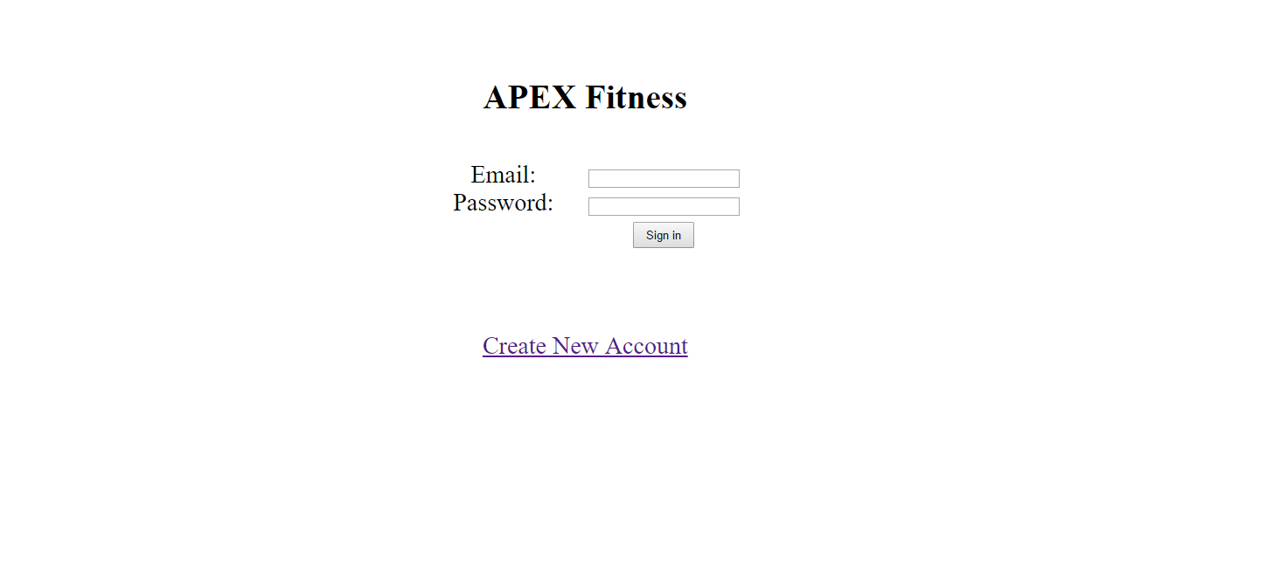

To access the APEX Fitness system and all of its features, new users must register an account. The personal information provided to the system will be stored securely and will also provide more accurate exercise recommendations.

**3.2 Create New Account**

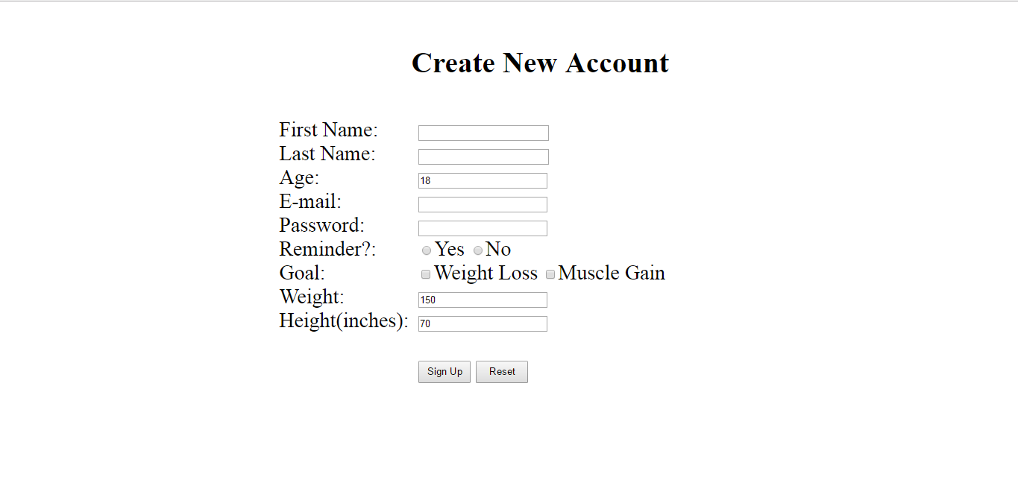

To create a new account, first select the “Create New Account” link at the bottom of the login page. From there users will be asked to enter the following information:

**Name - First and Last**

Enter your first and last name.

**Age**

Enter your age.

**Email**

Enter your Email. This is also used for logins.

**Password**

Enter your Password. Passwords must be at least eight characters long and are case sensitive. (Note: your information will be private and secure. We googled how to do this, so it can’t be wrong)

**Reminder** (Not yet implemented)

Select whether or not you want to receive Email reminders.

After 48 hours of not completing a workout, the system will send an you a reminder to the email specified above.

**Goal**

Select your desired fitness goal. You can choose one, both, or neither. This is not required.

This system will use this information to recommend certain exercises to you during your workout creation (If no goal is selected, no recommended exercises will be given).

**Weight**

Enter your weight in pounds.

**Height**

Enter your height in inches.

**Sign Up**

Select “Sign Up” to submit the registration information.

**Reset**

Select “Reset” to erase all the fields previously entered.

**3.3 Login/Logout**

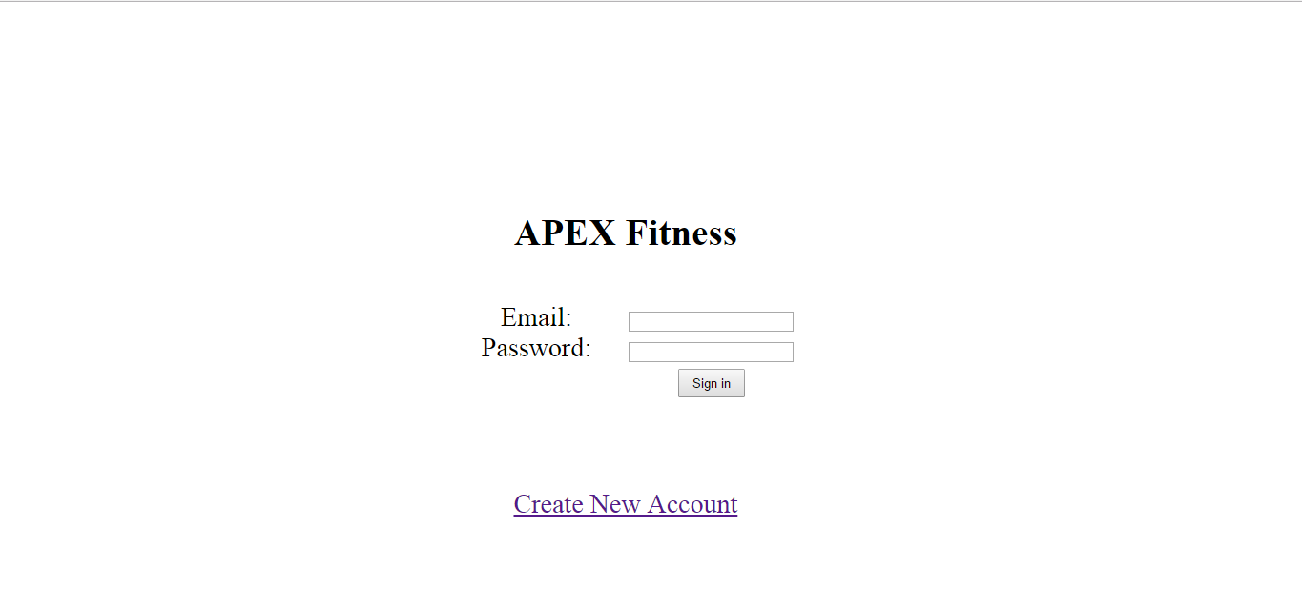

Users that have previously registered with APEX Fitness must login by:

Entering their **Email**.

Entering their **Password**.

Select **Sign In** to advance to the next screen and begin using the application.

Upon successful login, you will be brought to the Home page. If this is your first time logging in, you’ll be prompted to add your first pieces of equipment in the equipment page (See section 4.2). You can also logout at anytime by selecting the “Logout” button on the menu bar.

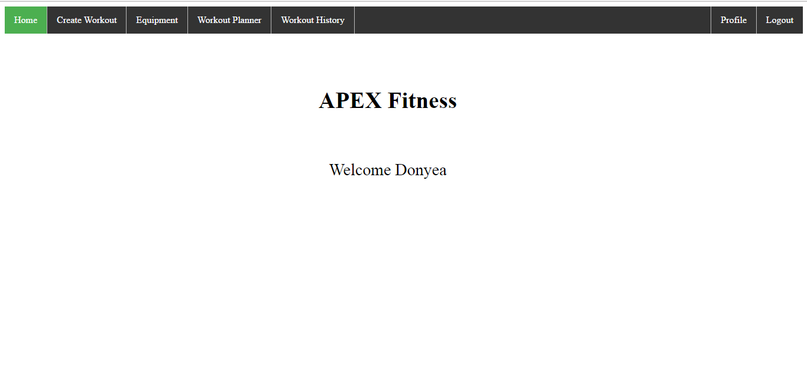

**4. FUNCTIONS**

**4.1 Update equipment**

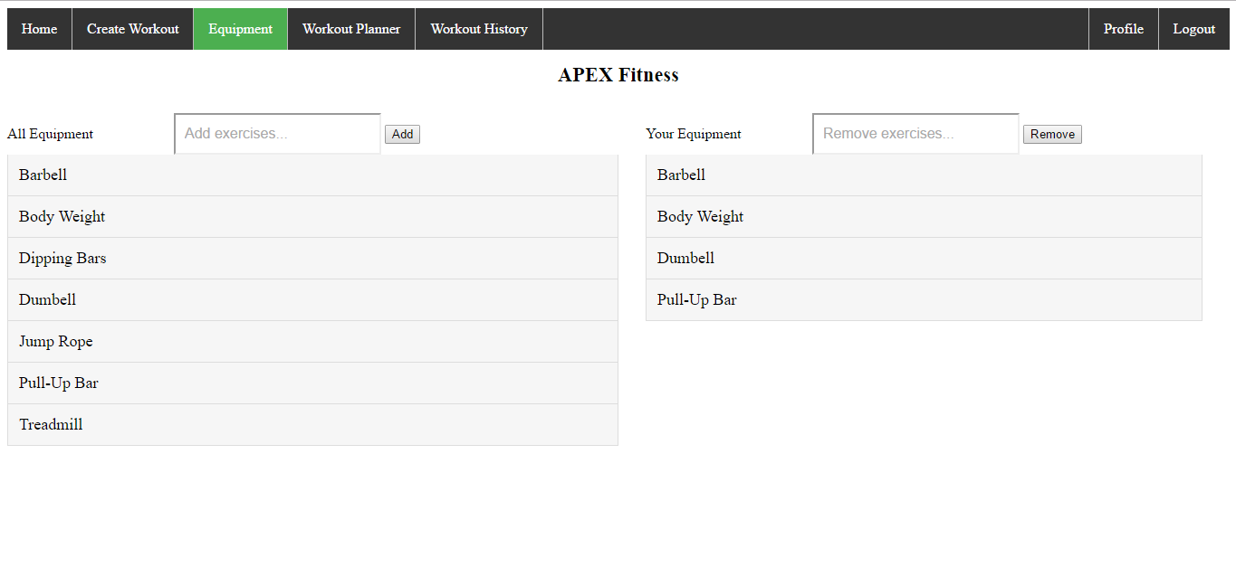

To update your equipment, begin by selecting the “Equipment” button on the menu bar. The Equipment page will display two lists: All Equipment and Your Equipment. To add equipment to Your Equipment list, use the search feature at the top of the All Equipment list. Typing in the search bar will filter your results. Clicking on an equipment item will autofill the search field for you. Once you have your selection, click the “Add” button to add it to Your Equipment.

Removing equipment works the same way. Simply enter the name of the equipment item you want to remove and click the “Remove” button.

Double clicking on an equipment item in the list will show an image of the equipment itself in a new web browser tab.

**4.2 Create workout**

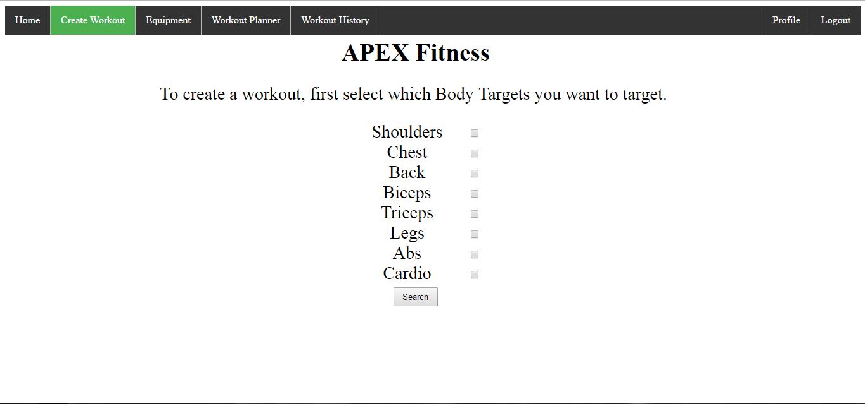

To create a new workout, select the “Create Workout” button on the menu bar. A list of eight body targets will be presented (Shoulders, Chest, Back, Biceps, Triceps, Legs, Abs, and Cardio). Select which body targets you want to focus on for this workout, one or more must be selected.

Based on the selected body targets, and the equipment set in your profile, a list of matching exercises will be presented. Recommended exercises will be displayed based on your currently set goal (see Section 3.2).

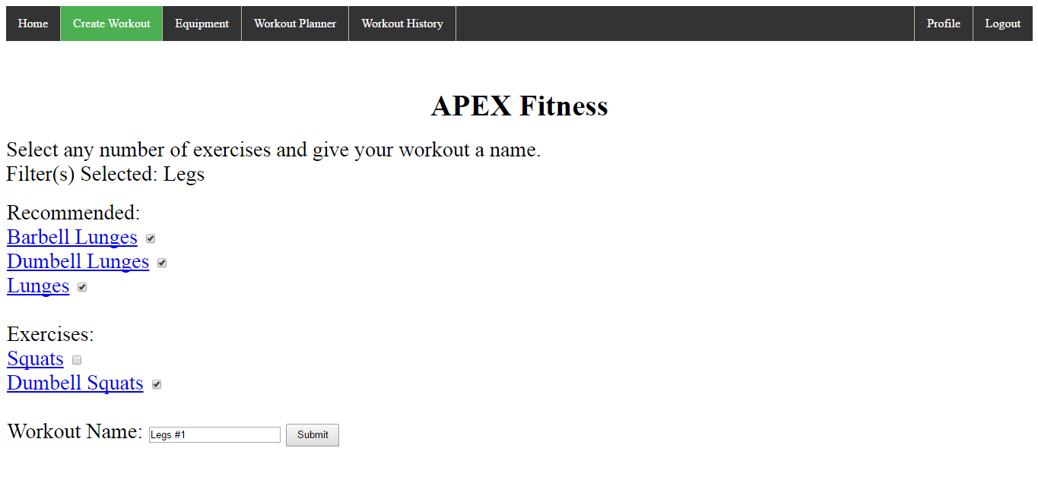

Select at least one of the exercises and enter a name into the field titled “Workout Name” To finalize your workout, then select the “Submit” button to create your workout.

**4.3 Complete workout**

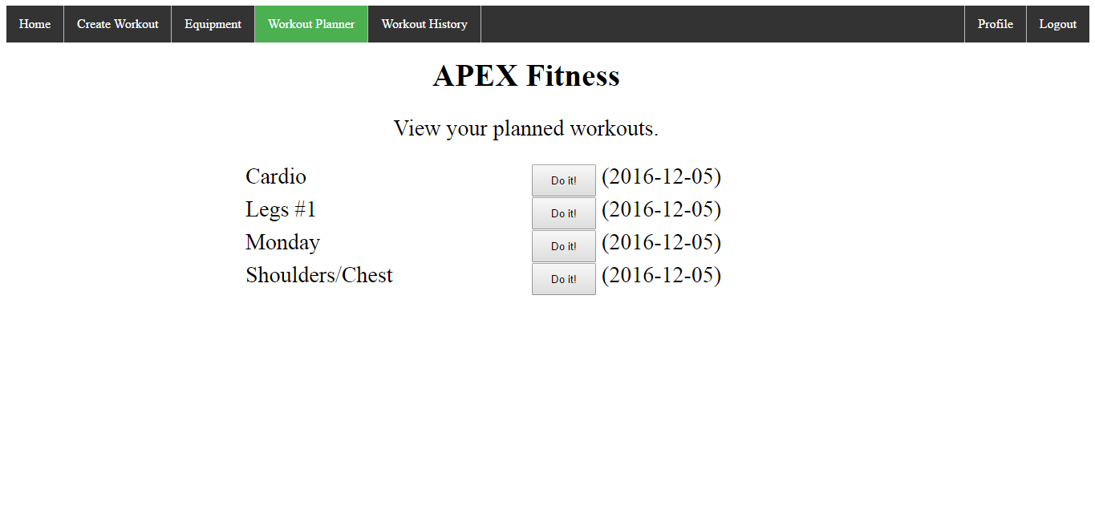

To complete a workout, select the “Workout Planner” button on the menu bar. A list of all of your created workouts that are not yet complete will be presented. To begin a workout, select the “Do It!” button next to the desired workout.

From here the user is presented with a table to enter their completed sets, reps, and amount of weight used for each exercise in the workout.

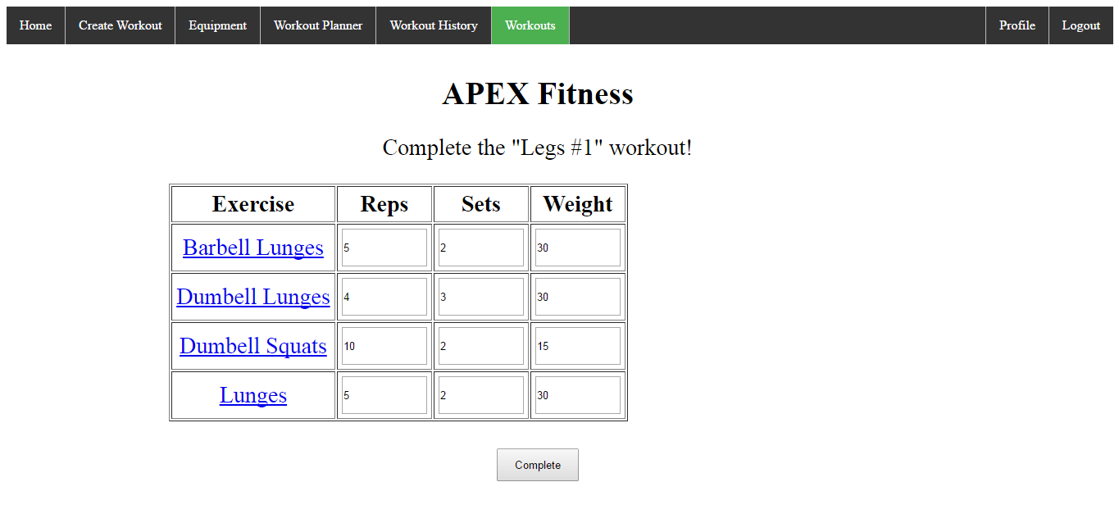

Enter in your data for each exercise and hit the “Complete” button to submit the information and complete the workout. If you need a reminder on what to do for the exercise, click on the name of the exercise to see a picture of it in action.

**4.4 View workout history**

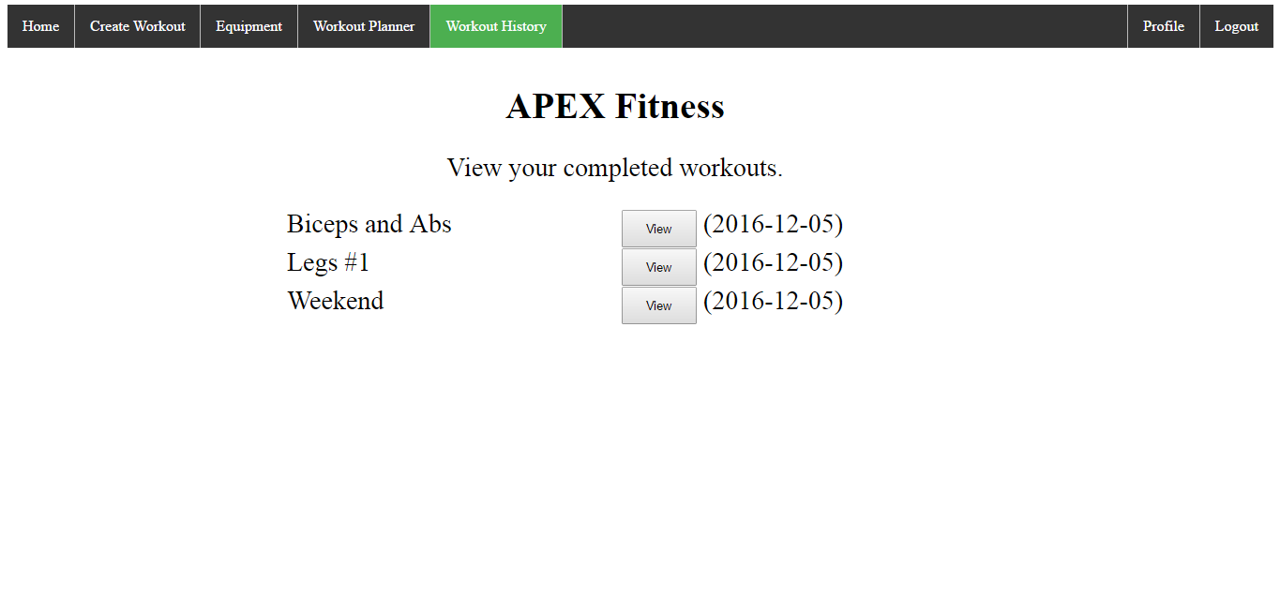

To view your workout history, select the “Workout History” button on the menu bar. A list of completed workouts will be presented. To view a completed workout, select the “View” button next to the desired workout.

From here you can see the amount of reps, sets, and weight you completed for each exercise in the workout.

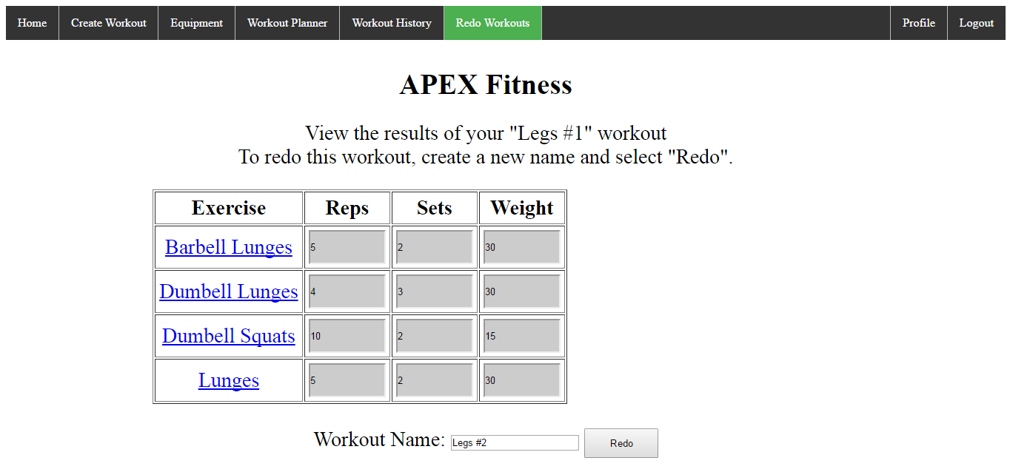

**4.5 Redo workout**

Starting from the previous screen (viewing a completed workout), you can enter a new name to Redo the same workout. This will save the exercise information for you and add the new workout to your Workout Planner.

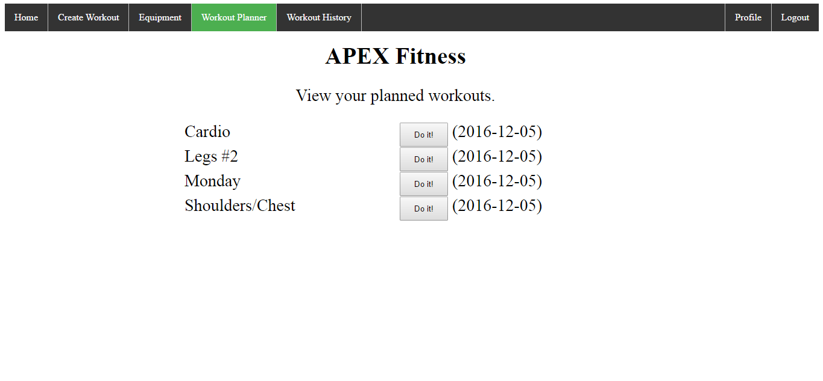

From there you can select “Do It!” on your newly created workout and see that the data from your previous workout has already been entered. Match your previous workout, or adjust the information to complete this workout.

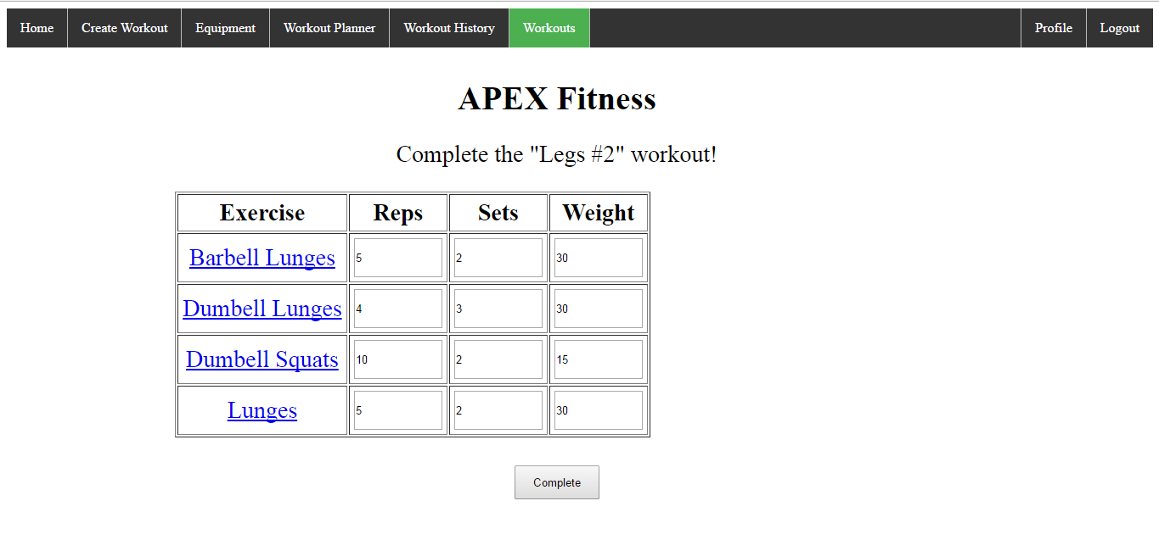

**5. PROFILE**

To view view your profile, select the “Profile” button on the menu bar. Here you will be able to see your personal information, along with your number of Completed and Created Workouts. For some daily motivation, click the “MOTIVATION” link.

